MEHRAN UNIVERSITY

OF ENGINEERING & TECHNOLOGY

JAMSHORO, PAKISTAN

Subject: Software Construction and Development

(Lab 5 - Tasks Solution)

|  |  |
| --- | --- |
| **Roll No:** | **22SW028** |
| **Section:** | **I** |
| **Name** | **Arbab Hussain** |

**LAB 05 TASKS (Manual Testing)**

**Tested the features of Food Panda Website Manually**

**1. Test Case for Restaurant Search Feature**

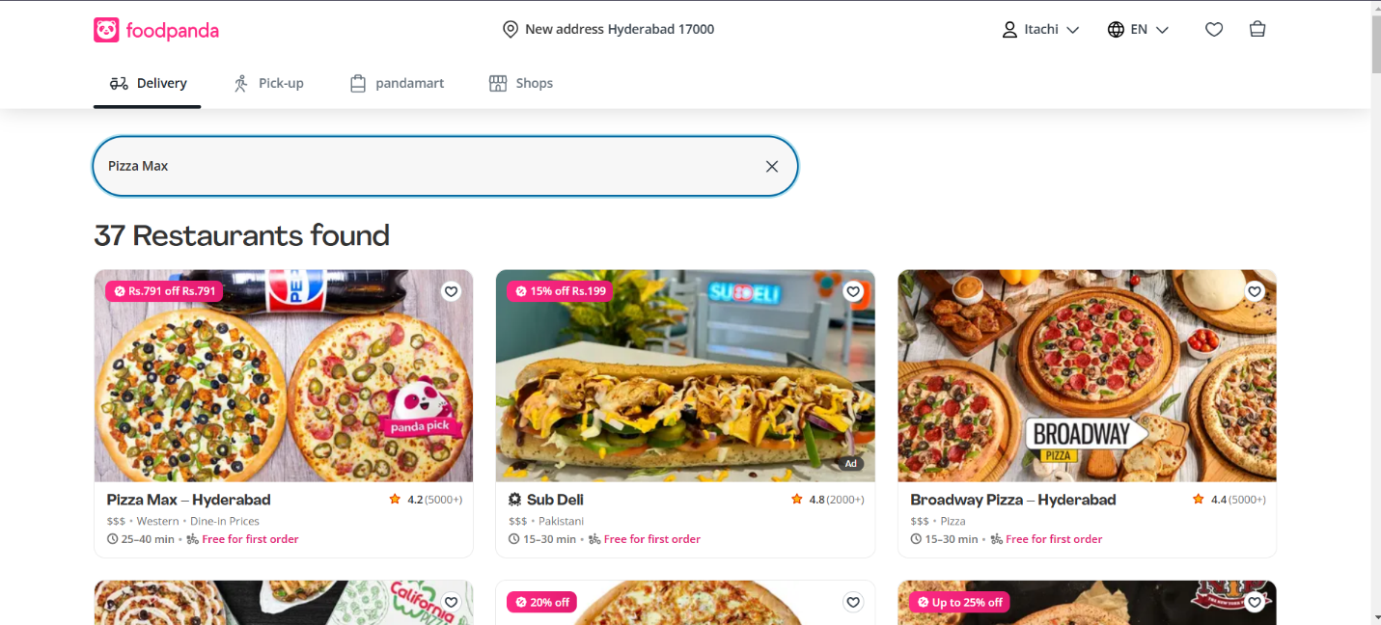

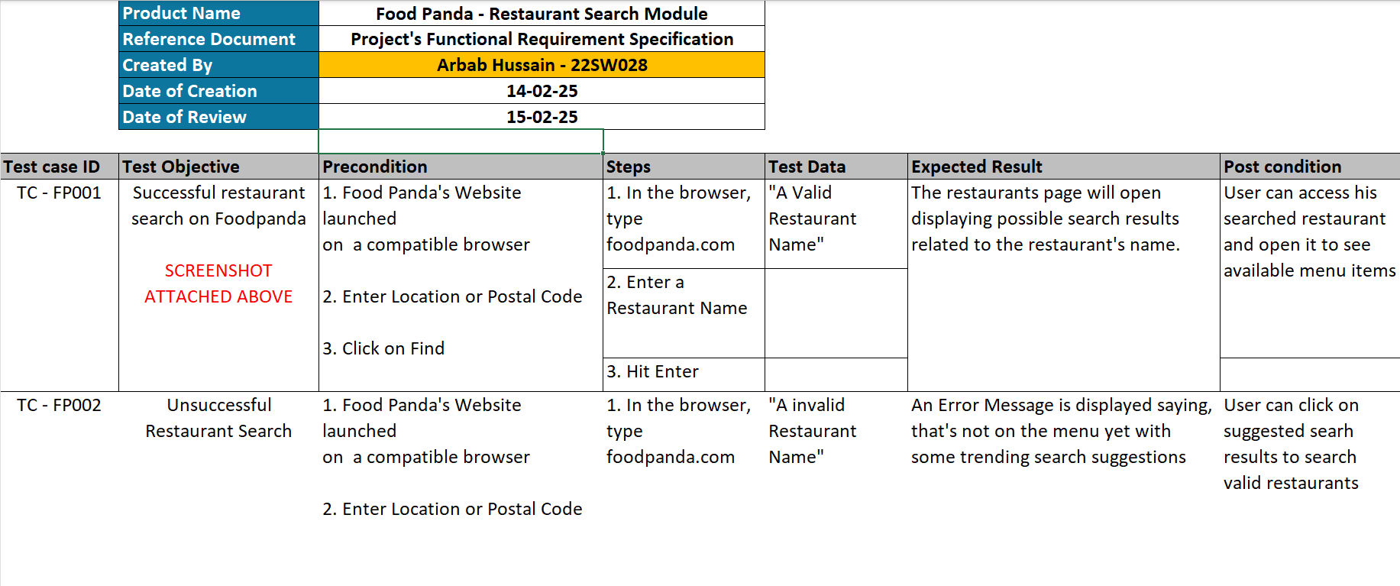

**1. Test Case for Filter Feature.**

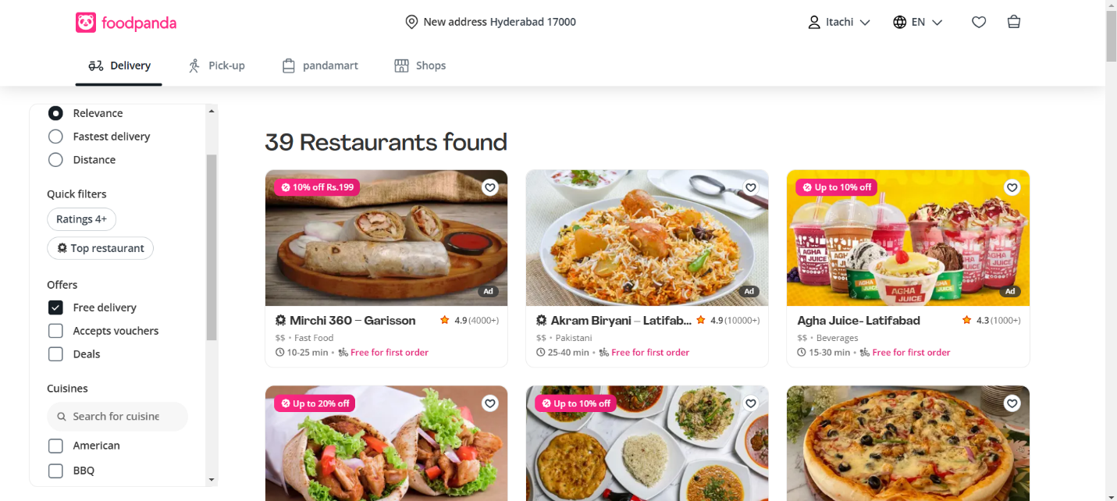

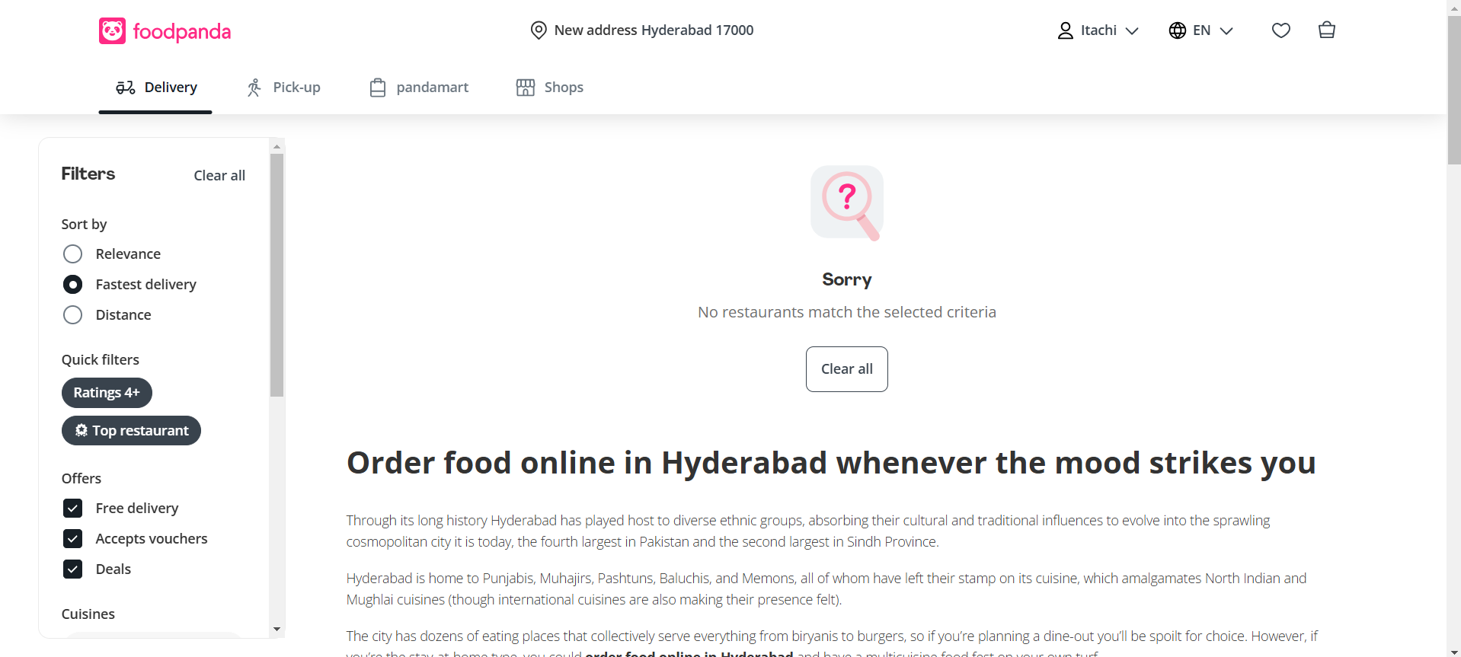

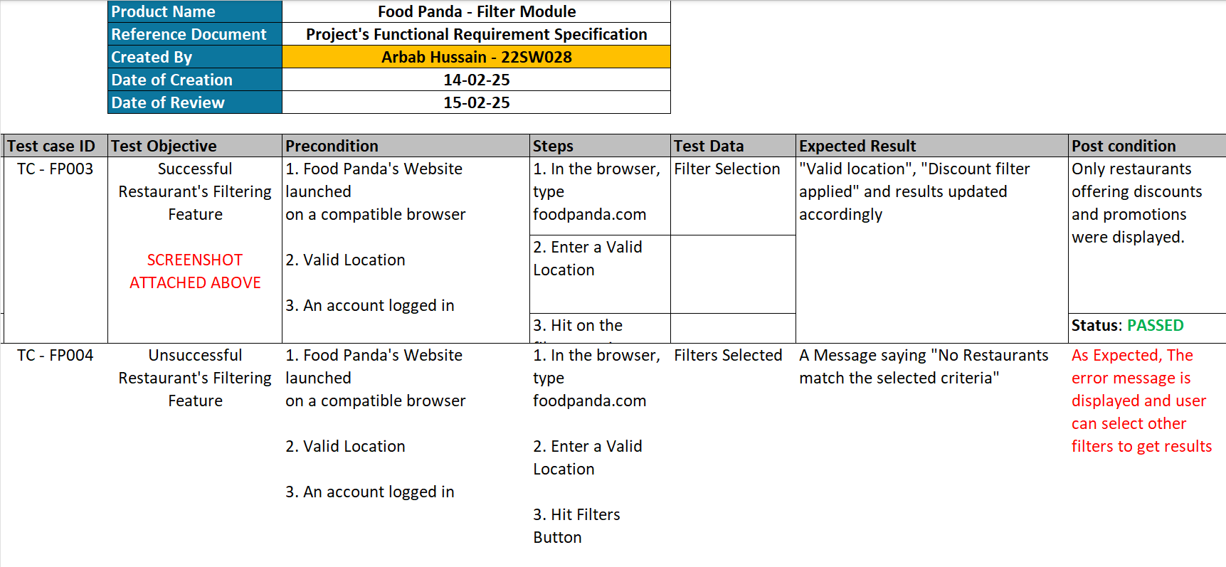

**3. Test Case for Cart Feature.**

